# 

Increasing voluntary engagement with employment support

Findings from a test and learn pilot led by camden council

**Written by:** Tom Pollard, Rachel Beddow, Zoe Tyndall

**Published:** August 2025

New Economics Foundation

[www.neweconomics.org](http://www.neweconomics.org)

[info@neweconomics.org](mailto:info@neweconomics.org)

+44 (0)20 7820 6300

NEF is a charitable think tank. We are wholly independent of political parties and committed   
to being transparent about how we are funded.

Registered charity number 1055254

© 2025 The New Economics Foundation

# Contents

Contents 2

Executive summary 3

Introduction 5

Background and context 6

The process we followed 7

Insights from the discovery phase 9

Outcomes of the experiment phase 14

Key lessons from the Pilot 18

Recommended next steps 21

Endnotes 26

# Executive summary

Between March and May 2025, Camden Council and the New Economics Foundation (NEF) collaborated on a 12-week test and learn pilot to explore how to improve voluntary engagement with employment support. The pilot was targeted at people in the limited capability for work-related activity (LCWRA) group of universal credit – people exempt from mandatory jobcentre requirements because of disabilities and health problems – to test whether proactive outreach from the council could increase levels of voluntary engagement with employment support.

The design of our approach and our communications were based on discovery interviews with residents in the LCWRA group and were iterated based on feedback and insights gained as the pilot progressed. We made proactive contact with residents in the LCWRA group to offer a support conversation, covering a range of issues, including employment. The conversations with those who opted in often led to referrals into other sources of support, including, in 42% of calls, employment support. This equates to 4% of the entire cohort we contacted, based on just one pass at a sequence of communication and touchpoints over around four weeks.

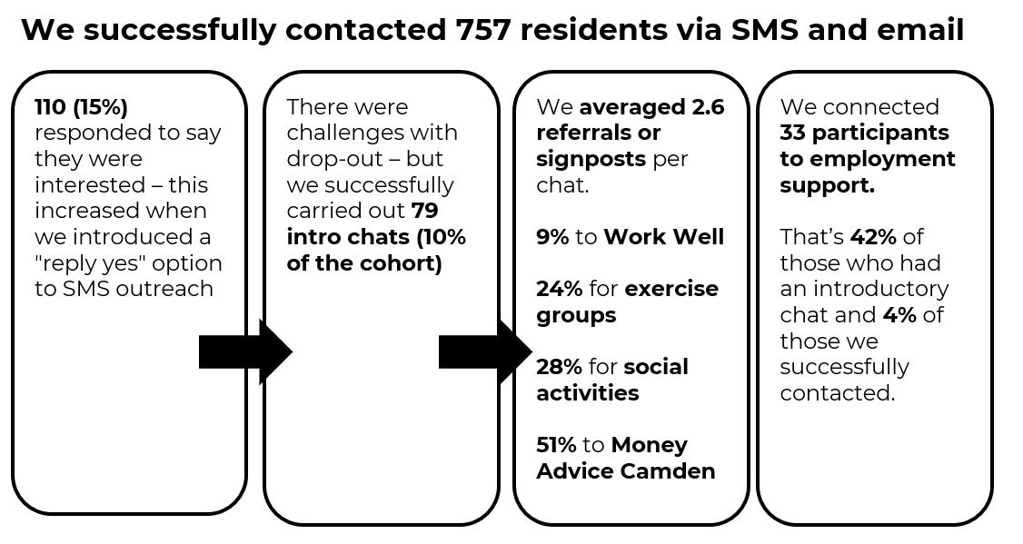

Source: Camden Council slides from the test and learn show and tell sessions

Key insights from the pilot include the following:

1. **Framing and tone enabled engagement:** The support call was framed as an informal, supportive, and optional conversation, not centred explicitly on employment; this was central to why residents chose to take part.
2. **Prioritising connection helped to widen the discussion**: Residents described the conversations as unusually respectful, kind, and patient. For many, it was the first time in years they had felt listened to without being judged or rushed.
3. **Readiness fluctuates, easy reconnection is key:** Many residents weren’t ready to take steps towards employment, but still expressed interest. Offering tailored, no-pressure follow-up made it easier to stay connected and return when ready.
4. **Confusion about the LCWRA rules created fear and inertia:** Many residents misunderstood what they were allowed to do while in the LCWRA group. They needed support and encouragement to take the first steps towards employment.
5. **Structural barriers limited the ability to act:** Even among residents who were motivated, many felt unable to take practical steps towards work or training due to unmet basic needs, like unsuitable housing and financial insecurity.

Our key recommendations to national and local government are as follows:

1. **The Department for Work and Pensions (DWP) should oversee local authority comparators alongside its efforts to increase voluntary engagement**: This would allow a more structured and formal comparison of the potential benefits of local-authority-led proactive outreach to the LCWRA group, rather than this being led by jobcentres.
2. **Local areas should build on the lessons from the Camden pilot with their own test and learn pilots:** Local areas need to increase the flow of people in the LCWRA group engaging with employment support. There is a clear return on investment to be made if more people are supported into work.
3. **National and local government should test key aspects of proactive outreach to this cohort and coordinate learning:** There are substantial opportunities to improve on the rates of initial engagement and the take-up of employment support we were able to achieve in the Camden pilot, including:

* Pre-screening the cohort to allow more proactive outreach.
* Strategically timing and targeting the offer.
* Carrying out deeper testing of what makes for an effective conversation.
* Working with trusted community partners and the NHS.
* Extending and expanding initial attempts at engagement.
* Offering different incentives and reassurances.

1. **Experimentation in this space should inform thinking about whether and how conditionality is applied to the LCWRA group:** Very little has been done in the past to engage this group on a voluntary basis - substantial efforts to do so should be made before any consideration is given to applying conditionality.

# Introdcution

Between March and May 2025, Camden Council and the New Economics Foundation (NEF) collaborated on a 12-week test and learn pilot to explore how to engage more Camden residents who are out of work due to disabilities and poor health with an offer of a call to discuss support available in the borough, including around employment.

By ‘test and learn’ we mean an approach of user-centred design with rapid feedback and iteration, led by a multidisciplinary team that brings skills and expertise such as frontline experience, user research, behavioural insights, and data analysis.[1] This type of approach is being advocated through the Cabinet Office’s Test, Learn, and Grow agenda.[2]

This report explains the background and context for this test and learn pilot, the process that was followed, the insights that were gained, and the outcomes that were achieved. It also explores how the learning and experience from the pilot could be built on in other parts of the country and through national-level policy and practice.

# Background and context

The number of people who are out of work and not actively seeking employment (often referred to as ‘economically inactive’) due to disabilities and poor health has increased significantly in recent years, particularly in the wake of the Covid-19 pandemic. This has become a growing focus of political concern, given the implications for the individuals affected, the labour market, the benefits system, and wider public services.

A key barrier to supporting this group towards work is that little has been done to proactively reach out and offer help. Because people in the limited capability for work-related activity (LCWRA) group of universal credit do not have mandatory requirements to prepare for or seek work, there has often been an assumption in the national policy debate that little can be done to engage this group with an offer of support.

In August 2024, NEF produced a policy paper calling for a test and learn approach to improving voluntary engagement with employment support among this those in the LCWRA group.[3] NEF argued this was necessary not only because this group is exempt from conditionality, but also because voluntary engagement is more likely to be genuine engagement, and is therefore more likely to lead to positive outcomes.

This paper built on extensive research by NEF on the role of conditionality (ie mandatory requirements for people who receive benefits, under threat of sanctions) in effective employment support.[4] The key recommendation from this was that any conditionality should be pushed into the background of the relationship between an individual and an employment support service, opening up as much space as possible for genuine engagement and only being made explicit as a last resort. The government’s white paper on improving employment support, published in November 2024, reflected this proposal to ‘background’ conditionality, and had a strong focus on improving the quality of engagement with people out of work due to disabilities and poor health.[5]

Camden Council had pre-existing interest, experience, and expertise in rapid, iterative test and learn approaches to designing and delivering services for residents and has long championed this way of working across several service areas. This pilot fitted well into their wider portfolio of welfare support, which takes a proactive, data-driven approach, and their investment in their in-house employment and skills service, Good Work Camden, which includes a specialist Disability Jobs Hub. Camden and NEF decided to collaborate on a 12-week test and learn pilot, which began in March 2025.

# The process we followed

The 12-week test and learn process was split into three phases – discovery, experiment, and analysis (see Figure 1). We conducted weekly ‘show and tell’ calls, open to internal and external stakeholders, to share what we had done each week, discuss insights, and seek input. These calls were attended by a wide range of stakeholders from national and local government, the third sector and academia, who provided invaluable guidance. This augmented the existing expertise within the project team around service design, resident engagement, employment support, social security, and behavioural insights.

The first four weeks of the test and learn process were spent in a discovery phase, where we interviewed 22 residents in the LCWRA group about their current circumstances, previous experiences of employment and employment support, and their hopes and fears about the future. We used these insights to develop the design of the experiment phase and communication materials, which we iterated based on resident feedback.

**Figure 1. Stages of the 12-week test and learn process**

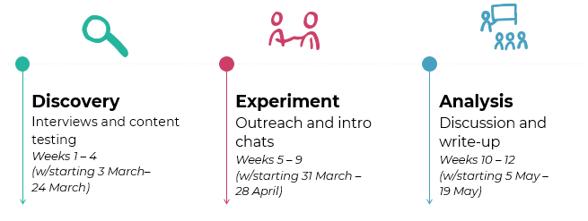

Source: Camden Council slides from the test and learn show and tell sessions

We spent the next five weeks in the experiment phase, where we sent communications out to 800 residents in the LCWRA group (we were only able to reach 757 due to issues with contact details) to try to engage them with the offer of a support conversation. We identified these residents through the Universal Credit Digital Service data (accessed through Policy in Practice’s LIFT tool[6]). It should be noted that this only contains around 80% of residents in the LCWRA group due to DWP data-sharing restrictions.

We sent text messages or emails to batches of 200 residents at a time, asking if they would be willing to opt in to a support conversation and linking to a website that contained more details, including an introduction to two named members of Camden Council staff who would be conducting the calls (see Figure 2). We iterated aspects of this outreach between the batches of communications, for example, altering the time of the message and making the opt-in process more straightforward.

**Figure 2. Communications sent to residents in the LCWRA group**

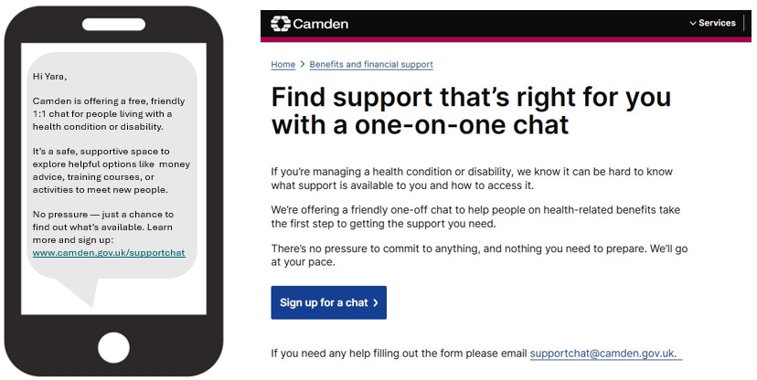

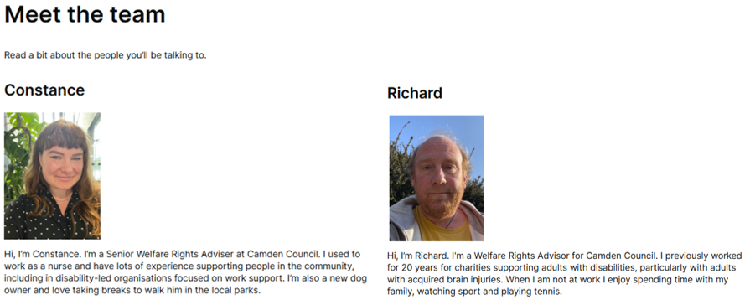

 Source: Excerpts from the Camden Council communications to residents as part of the pilot

We attempted to follow up with those residents who opted in to a support conversation. As we began to conduct these conversations, we also iterated the content and communication style based on insights and reflections from the staff delivering them. Based on the needs and wishes identified in these calls, residents were referred to other services, including employment support, where appropriate.

We spent the final three weeks in the analysis phase, where we reviewed the data and insights the experiment had produced. We also conducted follow-up interviews with 18 residents who took part in support conversations, to seek their reflections on the experience and what had happened since.

# Insights from the discovery phase

The 22 interviews with residents in the LCWRA group we conducted for the discovery phase helped to inform the experiment design. They also provided valuable insights into the challenges of engaging this group with employment support and, ultimately, with work. We identified key barriers (see Figure 3), including the impact of health conditions and disabilities, fears about employment support and the benefits system, and people’s doubts about their ability to work and how supportive employers would be.

**Figure 3. Landscape of barriers to engage in employment support**

Source: Camden Council analysis of discovery interviews. COM-B is a behavioural science framework that suggests Capability, Opportunity, and Motivation interact to produce behaviour (eg taking up employment support), which in turn can influence these same factors.[7]

The interviews also revealed key motivating factors for why residents in the LCWRA group may want to engage with employment support and the prospect of returning to work (see Figure 4). These discussions provided insights into the nature of an employment support offer that might effectively tap into these motivators.

**Figure 4. Motivators to engage in employment support**

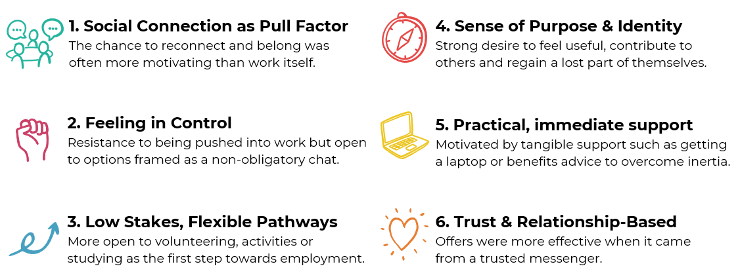

  Source: Camden Council slides from the test and learn show and tell sessions

Based on these interviews, we developed four composite personas that represented the different levels of motivation and capability for work we had heard from residents (see Figure 5). Although we ended up designing the experiment phase with personas such as Rashid and Layla in mind, personas such as Brian and Sofia offer valuable insight into why some residents may be reluctant to take up an offer of support.

**Figure 5. Who are we designing for? Exploring readiness through four personas**

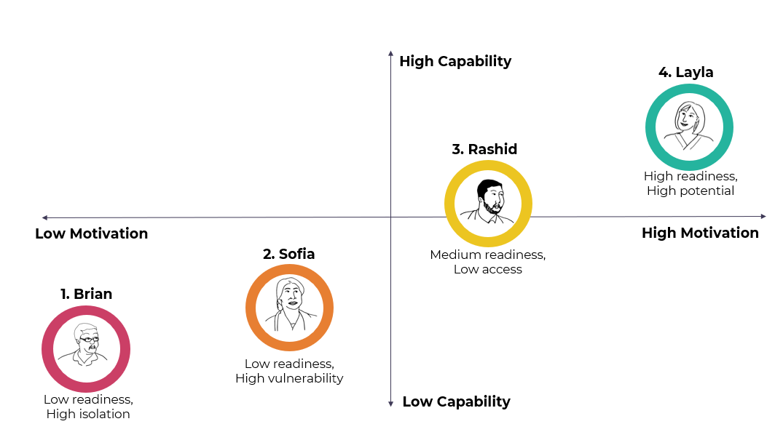

  Source: Camden Council slides from the test and learn show and tell sessions

Both Brian and Sofia feel that work is an unrealistic prospect for them (see Figures 6 and 7). They feel overwhelmed by the prospect of engaging with employment support – Brian primarily due to isolation and the time that has passed since he last worked; Sofia due to finding it hard to cope with day-to-day life due to trauma. Both could see the potential benefits of work, but doubt they could cope with the process of moving towards employment or the demands of a job and are reluctant to risk disrupting their current circumstances. However, sustained attempts to offer support around other aspects of their lives could potentially open up a future conversation about employment.

**Figure 6. Persona 1: Low readiness, high isolation**

**Brian - 58, lives alone, worked for a shipping company for over 25 years before a work-related back injury. Feels too far removed from work but misses the sense of connection and purpose. 

**

Source: Camden Council slides from the test and learn show and tell sessions

**Figure 7. Persona 2: Low readiness, high vulnerability**

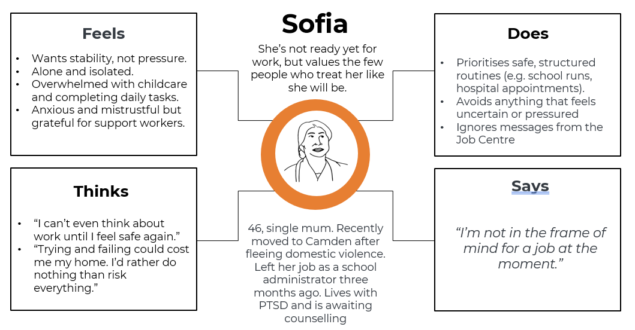

Source: Camden Council slides from the test and learn show and tell sessions

In contrast, Rashid and Layla are more open to the possibility of engaging with support or even moving into work (see Figures 8 and 9). Rashid is wary about this journey but is keen to explore what sort of volunteering or training might be available. Taking the first step is daunting for him, and so he would need supportive and sustained contact. Layla is more ready to consider a return to paid employment, but is confused about the implications for her benefits and hasn’t been able to find the right kind of support. She is frustrated after reaching out for help but not getting a sustained response.

**Figure 8. Persona 3: Medium readiness, low access**

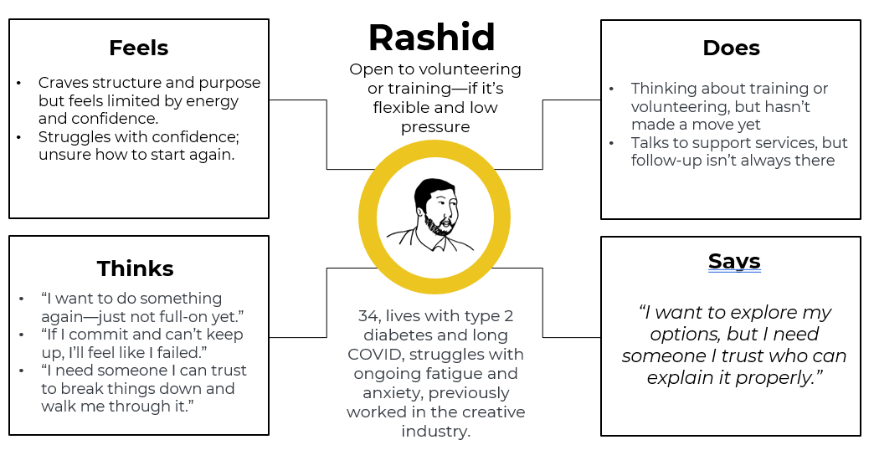

Source: Camden Council slides from the test and learn show and tell sessions

**Figure 9. Persona 3: High readiness, high potential**

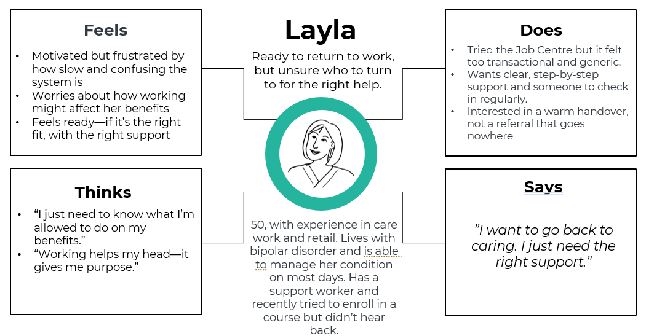

Source: Camden Council slides from the test and learn show and tell sessions

Building on these personas and the insights that informed them, we set out some key principles for the design of the proactive outreach we wanted to conduct in the experiment phase (see Table 1). Key to this was a communication style that reassured people, avoided putting them under any kind of pressure, and aimed to ensure they felt

|  |  |  |
| --- | --- | --- |
| **Design Principles** | **Why it matters (Insight)** | **How to apply it (Comms Tactics)** |
| Make it Emotionally Doable | Life already feels overwhelming for this cohort. Messages must feel light, manageable, and low-effort. | Use calm, gentle tone. Emphasise “no prep” / “no pressure” |
| Speak Like a Human, Not a Service | People are more likely to respond to the people, not the service (e.g. MAC) | Use advisers' names and share their background. Avoid an institutional tone. |
| Disarm Fear Upfront | Fear of judgement, pressure, or losing benefits is real — and blocks engagement. | Clearly say “this intro chat won’t affect your benefits.” Reassure there’s no pressure to work. |
| Be Clear and Concrete About Support | Abstract offers don’t land. People want to know: what exactly can you help with? | Name practical topics: “money advice, or join a walking group” Use plain English, not “holistic support” or “referral” |
| Speak to Purpose and Connection | What motivates people isn’t just work — it’s meaning, belonging, and routine. | Highlight options like volunteering, being part of something. Talk about feeling more steady or confident. |
| Let Them Stay in Control | People need to feel agency — not that they’re being signed up or assessed. | Emphasise choice: “Only if it feels useful”, “Your call” Avoid scripts, forms, or ticking boxes. |

in control of the discussion and any follow-up, such as onward referrals.

**Table 1. Setting design principles**

 Source: Camden Council slides from the test and learn show and tell sessions

Another critical insight from the discovery phase was the importance of framing the initial outreach as a wider offer of support rather than just focusing on employment. Although people do not follow a linear journey towards a return to work, they will start at some level on the ‘ladder of engagement’ (Figure 10) and may need to take interim steps before they feel ready to engage with employment support or seek a job.

**Figure 10. Ladder of engagement with employment support**

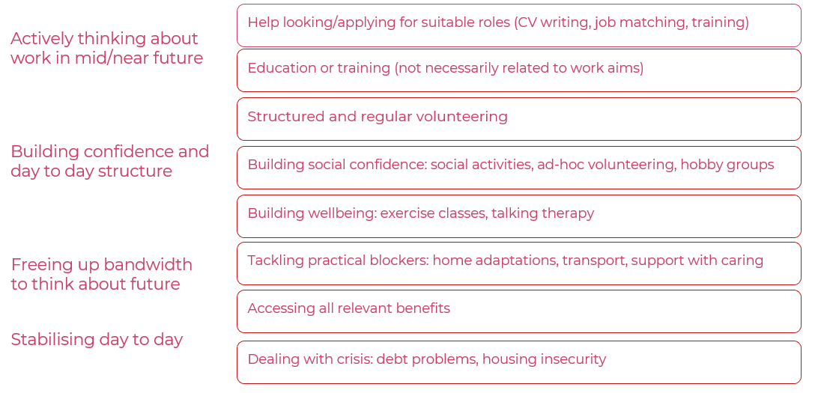

Source: Camden Council slides from the test and learn show and tell sessions

Many residents were not only wary of employment support and the potential implications for their benefits, but also faced a wide range of barriers (eg housing, debt, and access to health support) that often stood in the way of being able to think about a return to work. As such, proactive outreach that focuses too heavily up front on an offer of employment support is likely to deter many people from engaging who may ultimately benefit from this support if other factors could be overcome.

# Outcomes of the experiment phase

From the pool of 800 residents in the LCWRA group we targeted, Figure 11 sets out the interactions we were able to have with the 757 residents we managed to contact. Although only 4% of this cohort went on to a referral for employment support, this was based on just one pass at a sequence of communication and touchpoints over a period of around four weeks. Over a longer period, sustained efforts could lead to a greater proportion taking up support, either as a result of fluctuations in their willingness and ability to engage, or based on improvements in the engagement approach.

For example, in the most successful batches of initial contact, around 18% of recipients responded compared to the 15% average across all four batches. This seemed to be based on the timing of the message and a simpler process to opt in for a support call. We also did not have the capacity to make extensive efforts to engage the 31 people who did not complete a support call despite initially expressing an interest.

**Figure 11. Progression of residents through stages of engagement**



 Source: Camden Council slides from the test and learn show and tell sessions

The Camden Council staff who conducted these conversations gave a subjective assessment of the level of engagement that each resident demonstrated during the calls (see Figure 12), as well as their capability and motivation to engage with employment support (see Figure 13). They perceived the vast majority (81%) of residents they spoke with to be engaged or very engaged with the call. It was more of a mixed picture when it came to perceived levels of motivation and capability, with just over a third of residents spoken to rated as very low on both, and the rest fairly evenly spread across each vector.

**Figure 12. Level of perceived resident engagement during the support chat**

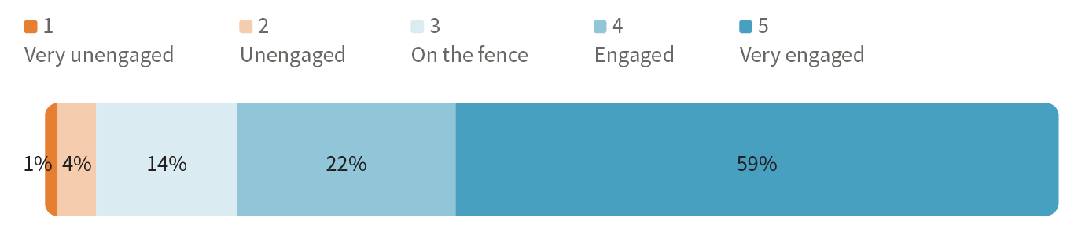Source: Camden Council analysis based on staff assessments of support conversations

**Figure 13. Perceived motivation and capability of residents during the support chat**

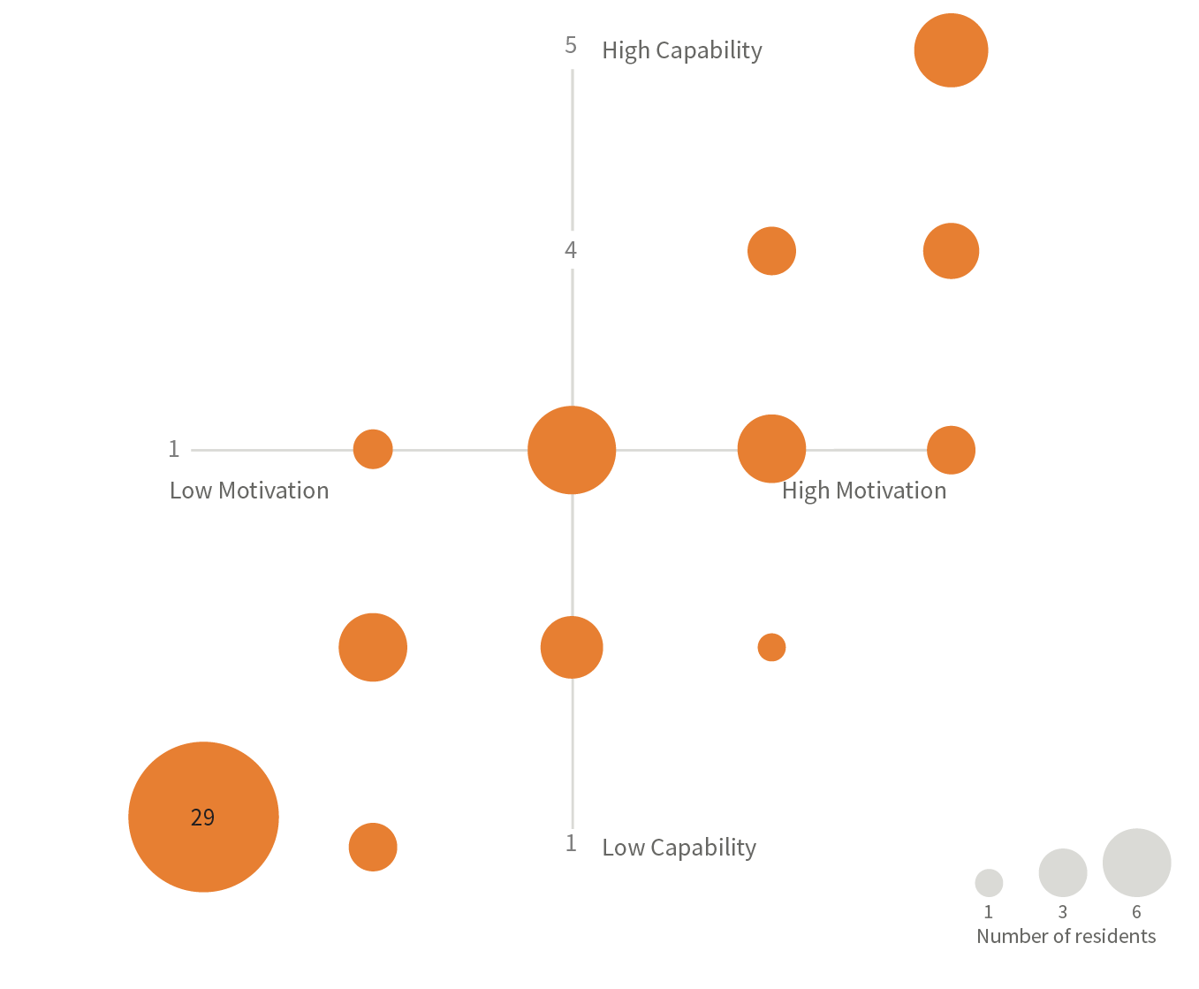

Source: Camden Council analysis of support conversations

The content and style of the calls were also iterated throughout the experiment, as the staff conducting the calls developed experience in conducting the calls and reflected on lessons learned from initial calls and feedback from the weekly show and tell sessions with internal and external stakeholders. Given the scale, timeframe, and staff capacity during the experiment, we were limited in our ability to formalise some of this learning, for example, through A/B testing messages or analysing transcripts of conversations. These types of approaches would add valuable insights, but it is also vital to allow for individual staff members to get a feel for how to conduct effective calls. More details on the approach taken within the experiment phase can be found within a separate [toolkit document that Camden has produced](https://www.camden.gov.uk/documents/d/guest/camden-council-employment-support-toolkit).

Almost 90% of the support calls led to some kind of onward referrals, with most residents put in contact with two or more services. Alongside support with finances, exercise, and social activities, 42% of calls led to residents being connected with employment support – mostly via Camden’s in-house service Good Work Camden, but also via a local NHS-based service called Work Well. We will continue to monitor the impact of this contact in terms of employment outcomes at 6 and 12 months and will compare this to a control group that was established at the start of this project.

**Figure 14. Overview of referrals residents received after their support chat**

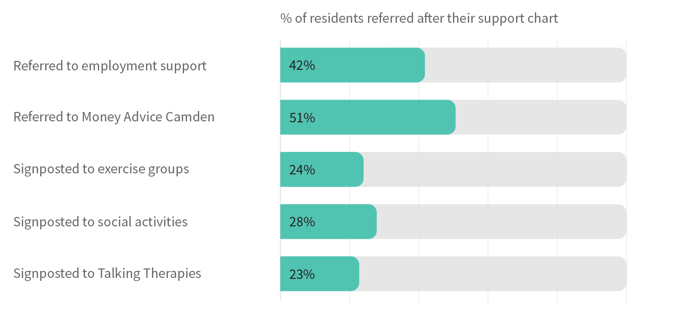Source: Camden Council analysis of support conversations

These pen portraits (Figure 15) give a sense of the range of circumstances, aspirations, and barriers of residents spoken to during the experiment, the conversations Camden staff were able to open up, and the onward referrals they were able to facilitate.

**Figure 15. Pen portraits of residents who engaged with a support chat**

Chloe is a 26-year-old woman, who has anxiety, depression, PTSD and depersonalisation syndrome.

She was previously homeless and struggles to leave the house without someone with her. She previously had a lot of support from services but feels like every dropped off when she turned 25 which made her "feel a bit bitter...I almost gave up". 

She previously worked as a pharmacy dispenser, and did try to return to work a few times but couldn’t maintain it. She has looked for work, made applications and was invited to an interview that she wasn't able to attend because she couldn’t leave the house that day. 

She was engaged in the conversation and happy to be connected with an employment advisor once she was convinced that they would be adaptable to her needs. Despite her willingness and motivation to work, it is clear that she will need adequate mental health support before she is able to get or sustain a role.

Outcomes:

Did an application for a Cost of Living Grant
Referred her to welfare rights team to review her PIP award level
Signposted to low cost therapy services 
Connected her with Good Work Camden to talk about a range of flexible optionsDanny is a 44-year-old man who lives alone.

Danny has bipolar disorder and autism, COPD and severe asthma, anxiety and depression. 

He worked for many years as a chef before his health conditions made it impossible to keep working.

Danny was pleased we'd got in touch - he had just been served a S21 (no-fault) eviction notice and didn't know where to turn, so our text came at a good time. He was open to the idea of work, but was clear he couldn't engage until he'd sorting his housing situation. 

He reflected that he's now very overweight and would struggle to go back to such a demanding role as being a chef. But would like to retrain and find accessible exercise options to begin recovering his health – but has no idea where to start. 

Outcomes:

We linked him to housing options information
We organised an appointment to get him a cost of living grant and benefits check
We signposted to local exercise 
We connected him with Good Work Camden, so he could talk to an advisor about training options which are right for him, at his own pace
Thiago is a trained dental nurse originally from Brazil. He  had been dismissed from a job after having a panic attack at work, and was living in near-total isolation. 

Despite this, he expressed a passion for helping others and had recently completed a theory course in Venetian plastering as a new vocational path. 

Thiago was highly engaged during the chat and motivated to act on support. He was able to speak about work and future aspirations.   

Outcomes:

We made a referral to a benefits advisor for support applying to PIP
Connected him with talking therapy and low-cost mental health services 
We linked him to Good Work Camden for support into flexible self-employment options


Source: Camden Council slides from the test and learn show and tell sessions  
*The names used in these pen portraits are not the real names of the residents we spoke to

# Key lessons from the pilot

The analysis phase of the pilot, along with the insights gathered during previous phases, indicates some clear lessons to be drawn about engaging with this cohort. The quotations used concerning each of these lessons are drawn from the follow-up interviews conducted with 22 residents who engaged with a support call.

### 1. Framing and tone enabled engagement

The way the offer of a support call was framed – as an informal, optional, and supportive conversation – was central to why residents chose to take part. The use of terms like “support” rather than “employment” or “assessment”, a focus on them setting the pace, and the fact that the offer was local reduced anxiety and encouraged participation. This cohort is often stuck in the very real present of a crisis – just proactively getting in touch to initiate thinking about the future can help psychologically reset and build confidence.

“The word ‘support’ caught my eye. It didn’t sound like someone was going to question me or make me feel bad. It sounded like help.”

“I got the text, the email, and to be honest that paranoia, depression part of me is like “Oh my god, they’re saying you need do this” and then when I re-read it and gave myself a bit of a talking to and was like no, they’re saying no, it’s 'at your own pace'.”

"Before, I felt isolated, and no one knows what I’m going through. It has changed my feelings – I feel like I’m included in something."

### 2. Prioritising connection helped to widen the discussion

Residents described the support conversation as unusually respectful, kind, and patient. For many, it was the first time in years that they had felt listened to without being judged or rushed. The non-directive tone helped them open up and reflect without fear of consequence. Many came with a single emergency issue but ended up engaging with other services, including training and job support. Many of those who didn’t take immediate action said it made them feel likely to do so in future. Choice is key – any sense of pressure would have derailed the process.

“It was one of the only times I felt like I could speak honestly about how things are for me. I felt seen and heard.”

"It was so lovely that it was warm. Other departments haven't been like this. I felt I could speak from my heart, be open about my challenges.”

“It helped me breathe a bit. I didn’t feel so stuck after.

### 3. Readiness fluctuates, easy reconnection is key

Many residents weren’t ready to register right away, but still expressed interest in the future. Others saw their readiness change day to day with fluctuating health conditions.  Offering tailored, no-pressure follow-up made it easier for them to stay connected and return when the time felt right.

“I’m interested in working again. But right now, my priority is just making it through the week.”

“It planted a seed. I’m not acting now, but when I do, I’ll know where to start.”

"I have a lot of trauma, but this isn’t forever ... I’m really pleased that I got that email, so I’ve got something to look forward to; it’s hopeful, isn’t it?"

### 4. Confusion about LCWRA rules created fear and inertia

A significant number of residents misunderstood what they were allowed to do while in the LCWRA. Some believed that expressing interest in work or taking part in training could risk their benefit entitlement. Many had attempted re-entry to work in the past and not been supported or seen their health rapidly deteriorate – creating real anxiety about trying again. Related to this, residents needed real support and encouragement to take the first step towards employment support or other services. Providing a leaflet or website would have been unlikely to lead to concrete action, but helping someone to fill out a form or booking an appointment for them was generally appreciated.

“I thought doing anything would mean I’d be punished. I didn’t know I could even look at courses.”

“I felt I wasn’t allowed to attempt progression. I was very worried to see what I could manage, and essentially the rug being pulled out from under me if I then found that I couldn’t manage.”

“She made it easy for me by breaking it all down into small steps.”

### 5. Structural barriers limited the ability to act

Even among residents who were motivated, many felt unable to take practical steps towards work or training due to unmet basic needs, like unsuitable housing, financial insecurity, and lack of access to mobility aids. Residents consistently emphasised the need for employment support to be integrated with broader services and flexible funding that addresses material constraints. They found the genuine range of options and lack of short-term pressure surprising, and it built trust quickly.

“I want to study, but I can’t pay for it.”

“My boiler is broken. That’s my focus right now. I can’t do anything until that’s fixed."

“I'm having a hard time getting a wheelchair, so I've just given up on work. The first step is being able to move, then I can think about other things”

The following lessons should be reflected in the design and delivery of services elsewhere that are looking to replicate and build on this test and learn pilot:

* **Use supportive, non-threatening language in outreach communications:** Framing the offer around “support” rather than “employment” and emphasising control over pressure or pace helped to facilitate genuine engagement.
* **Prioritise warmth and empathy:** The qualities of the conversation – patience, compassion, human tone – were central to fostering engagement, creating space for harder topics, like exploring the possibility of a return to work.
* **Allow for non-linear journeys:** Readiness fluctuates, especially with complex health conditions. Service design should make it easy to reconnect, and staff should treat small steps (like a conversation or a reflection) as valid progress.
* **Clarify entitlements**: Staff can play a vital role in correcting misunderstandings about what people can and can't do while in the LCWRA group, building confidence to explore employment support.
* **Simplify and pace follow-up**: Residents were more likely to act when referrals were clearly explained, paced appropriately, and followed up proactively.
* **Integrate with holistic support:** Employment conversations were often hindered by unresolved housing, health, or financial problems. Close working relationships across councils, NHS, and community services can help to address these wider issues and improve outcomes.

# Recommended next steps

Given that people in the LCWRA group cannot currently be mandated to attend employment support, and that the government has committed to substantial additional investment in employment support for this group, it is critical to try to increase levels of voluntary engagement with support. This test and learn pilot should provide impetus to expand efforts at proactive outreach to the LCWRA group and a solid foundation of materials and insights from which to build such efforts.

The DWP has been undertaking its own work to proactively reach out to this cohort and offer voluntary engagement with a jobcentre work coach.[8] This has produced what are seen as promising results of a three percentage point increase in employment outcomes compared to the baseline for an LCWRA cohort filtered for people it would be inappropriate to contact proactively (eg people with terminal conditions). We have had positive engagement with the DWP throughout and beyond the pilot about the lessons that can be learnt from both projects in combination.

To build on the Camden pilot and improve outreach to, and outcomes for, people in the LCWRA group, our recommendations for national and local government are as follows:

### 1. The DWP should oversee local authority comparators alongside its own efforts to increase voluntary engagement

Given that the DWP is planning to allocate more resources to build on the impact and insights of its own work to improve voluntary engagement through proactive outreach, we believe it should oversee a formal comparison with some local authorities. There is precedent for such an approach, such as with the Work and Health Programme, where local authorities are funded and supported to deliver an equivalent service to Jobcentre Plus or contracted provision.[9] This allows for locally-led experimentation around design and delivery, but with a level of evaluation from the DWP that allows them to directly compare the quality and impact of a similar service delivered in different settings.

In this context, it would be critical for the DWP to provide equivalent data to local authorities to allow them to conduct the same type of proactive outreach that has been delivered by some jobcentres in previous DWP experimentation. The primary point of comparison would be levels of performance, in terms of the proportion of people who engage initially, those who go on to take up employment support, and those who move into work. However, these comparators should also explore any variation in the characteristics and circumstances of people who progress to each of these stages, depending on whether it is a jobcentre or a local authority conducting the outreach.

### 2. Local areas should build on the lessons from the Camden pilot with their own test and learn pilots

Regardless of whether the DWP proceeds with formal local authority comparators or whether a particular area is selected to be part of this process, combined and local authorities should be thinking about how to be more proactive and systematic about their outreach to residents in the LCWRA group. The DWP should also be encouraging, facilitating, and supporting these efforts, for example, through their ‘trailblazer’ funding.

Combined and local authorities are seen by the DWP as having a key role to play in supporting this cohort towards work, as indicated by the devolution of powers and resources outlined in their 2024 *Get Britain Working* white paper.[10] However, there is a risk that improved local provision is not matched by proactive efforts to ensure a greater flow of people in the LCWRA group engaging with this provision on a voluntary basis.

As well as the benefits local residents might derive from engaging with support, there are significant economic gains to be made from supporting people towards work who may not otherwise engage with support. DWP modelling suggests that someone moving from the LCWRA group to full-time paid employment could generate £18,000 a year of direct fiscal returns (from lower benefit spend and higher tax returns) and wider societal savings of £28,000 a year, including increases in economic output. For someone moving into part-time work, the fiscal savings would be around £8,000 a year, with wider societal savings of around £15,000 a year.[11] Although up-front investment is required to foster engagement with this cohort and provide support with employment and wider issues, the potential savings far outstrip these costs.

Combined and local authorities may be better placed to realise and benefit from the wider societal savings, in terms of local growth and reduced pressure on public services, due to their ability to plug people into a range of local support and see the impact of this. They may also be able to reach and build a relationship with some people with whom the DWP would struggle to connect via jobcentres due to issues with reputation and past experiences. As such, national government should find ways to pass on some of the fiscal savings accrued when local government exceeds baseline expectations for the number of residents in the LCWRA group moving into work. Our initial estimates are that there should be a high return on investment for the staff time to achieve this.

Local government can learn directly from the approach taken in Camden from [the toolkit the council has produced](https://www.camden.gov.uk/documents/d/guest/camden-council-employment-support-toolkit). Even in the absence of better support from the DWP around data, local authorities should be confident in using the existing data they hold on residents who are in the LCWRA group. Other areas should adopt not just the approach developed in Camden but the test and learn methodology and ethos that formed the foundation of the pilot, following guidance from organisations such as Nesta.[12] It will be particularly important for this work to ensure conditions for great casework: reasonable caseloads, space for staff to focus on one type of work at a time, excellent digital systems, and minimum admin. It is also vital that staff measure impact by a broad range of outcomes, as narrow targets will lead to narrow behaviours.

### 3. National and local government should test key aspects of proactive outreach to this cohort and coordinate learning

We believe there are substantial opportunities to improve on the rates of initial engagement and the take-up of employment support we were able to achieve in the Camden pilot. Throughout the pilot, we identified a range of different approaches that could be tested and aspects that could be optimised that we weren’t able to fully explore in a 12-week process. We recommend the following variations be tested, but would also encourage further experimentation, led by test and learn principles and methodology:

* **Pre-screening the cohort to allow more proactive outreach:** The DWP should provide local authorities with more detailed data on the local LCWRA cohort that allows them to screen out people with characteristics that would make more proactive outreach inappropriate (eg terminal illness). In the DWP’s efforts to offer voluntary support to the LCWRA group, it has had success with making proactive outbound calls after sending people a message flagging that they would be doing so, but without seeking an opt-in, which may ultimately lead to increased rates of engagement.
* **Strategically timing and targeting the offer:** Test offering support at different points in people’s health and work journeys – for example, after a few months in the LCWRA group, or by using the fit note process to contact people who have recently stopped work and adding in an employment rights element to help with retention. Targeting younger people should also be explored – our cohort skewed older, but the younger residents we engaged with often lacked clarity or confidence about where to start.
* **Carrying out deeper testing of what makes for an effective conversation:** Having a greater number and variety of people conducting the support conversations would allow for more testing of what makes someone effective at this role. By recording and transcribing calls, AI analysis could be conducted to identify the key features of conversations that led to positive outcomes. Different media for the initial conversations could also be tested, such as video calls and face-to-face meetings, to test the impact on outcomes.
* **Working with trusted community partners and the NHS:** Test including staff from community groups (such as peer support services) and the NHS in the proactive outreach, whether as the initial point of contact or as part of referral pathways. Understand how levels of trust and prior relationships impact engagement levels and how this varies by people’s demographics and circumstances.
* **Extending and expanding initial attempts at engagement:** Investing more time up front in building a relationship with someone, perhaps over multiple contact points, rather than just using one call to make onward referrals, to explore the cost-benefit of how this impacts on eventual outcomes. Additional attempts to engage residents could be made over time, to reflect the fluctuating nature of many people’s health conditions and circumstances, and the impact this will have on readiness to engage.
* **Offering different incentives and reassurances:** The DWP’s introduction of a ‘right to try’ work, with less risk of it impacting on people’s benefit status, was a welcome feature of the *Pathways to Work* green paper.[13] A test and learn pilot around initial engagement offers an ideal opportunity to explore whether this reassurance is effective, how it should be communicated, and whether further incentives or guarantees could help to convince more people in the LCWRA group to engage with employment support.

National government should ensure that local experimentation is effectively coordinated and captured so that learning can be collated, shared, and iterated. The DWP has a key role to play in this, but the Cabinet Office’s Test, Learn and Grow programme could also help to promote the benefits and potential of further work to build on the Camden pilot and develop the capability of local areas to deliver effective test and learn processes.

### 4. Experimentation in this space should inform thinking about whether and how conditionality is applied to the LCWRA group

The *Pathways to Work* green paper set out plans to place mandatory requirements on the LCWRA group to attend jobcentre appointments to discuss employment support.[14] This represents a fundamental shift in the approach to this group, given that their current categorisation explicitly exempts them from such conditionality. While there is limited evidence that conditionality will help to move this group towards work, there is extensive evidence to suggest it could be risky and harmful and may undermine the type of genuine engagement that leads to positive outcomes.[15]

Legislating to apply conditionality to this group and then operationalising this is likely to take at least two years. Given this, and the additional resource being committed to employment support for this group in the intervening period, increasing voluntary engagement with support should be a central priority in the coming years. This work should also inform whether and how conditionality is eventually applied to this group. If rates of engagement with support can be significantly increased without recourse to mandatory appointments, the case for applying conditionality becomes even weaker.

The limited capability for work (LCW) group offers a unique opportunity for testing the relative merits of voluntary versus conditional engagement. This group has been assessed as having less substantial barriers to work, receives a lower rate of benefit, and can be mandated to engage in work-related activity. Despite this, their monthly return to work rate has only been around one percentage point higher than the LCWRA group.[16] The approach to proactive outreach piloted in Camden should be applied to a cohort in the LCW to attempt to foster voluntary engagement, and this should be compared to the experience and outcomes of a cohort with mandatory appointments.

At the very least, the pilot in Camden, and further test and learn work elsewhere that builds on this, should inform an approach with the LCWRA group where all opportunities for genuine, voluntary engagement are fully explored and exhausted before any kind of recourse to conditionality is invoked.

## Acknowledgements

We would like to thank Constance Attlee, Richard Swanton, Jun Nakagawa and Bonnie Cheng of Camden Council for their contribution to this work, as well as all the other stakeholders within and outside of the council who supported and fed in to the pilot. We would also like to thank abrdn Financial Fairness Trust for supporting NEF’s involvement in this project.

# Endnotes

1. Greenway, A., & Loosemore, T. (2024). *The radical how*. Nesta and Public Digital. <https://d1rnadml6vbx0i.cloudfront.net/Public-Digital_The-Radical-How.pdf>
2. Cabinet Office. (2025, 16 July). C*ommunities across the country to benefit from ‘innovation squads’ to re-build public services.* [Press release]. <https://www.gov.uk/government/news/communities-across-the-country-to-benefit-from-innovation-squads-to-re-build-public-services>
3. Pollard, T. (2024). *Better engagement for better outcomes: Taking a rapid test and learn approach to engagement with people out of work due to disabilities and poor health*. New Economics Foundation. <https://neweconomics.org/2024/08/better-engagement-for-better-outcomes>
4. Pollard, T. (2024). *Terms of engagement: Rethinking conditionality to support more people into better job*. New Economics Foundation. <https://neweconomics.org/2024/07/terms-of-engagement>
5. Department for Work and Pensions, HM Treasury and Department for Education. (2024). *Get Britain working white paper*. <https://www.gov.uk/government/publications/get-britain-working-white-paper/get-britain-working-white-paper>
6. Policy in Practice (n.d.). *Low income family tracker*. <https://policyinpractice.co.uk/low-income-family-tracker/>
7. Michie, S., van Stralen, M. M., & West, R. (2011). The behaviour change wheel: A new method for characterising and designing behaviour change interventions. *Implementation Science, 6*, 42.   
   <https://doi.org/10.1186/1748-5908-6-42>
8. Department for Work and Pensions. (2025). *The**impact of additional Jobcentre Plus support on the employment outcomes of disabled people.* <https://www.gov.uk/government/publications/the-impact-of-additional-jobcentre-plus-support-on-the-employment-outcomes-of-disabled-people>
9. Department for Work and Pensions. (2023). *Work and health programme evaluation.* <https://assets.publishing.service.gov.uk/media/65a6759b867cd800135ae927/work-and-health-programme-evaluation-synthesis-report.pdf>
10. Department for Work and Pensions. (2025). *Get Britain working white paper.*<https://www.gov.uk/government/publications/get-britain-working-white-paper>
11. Department for Work and Pensions. (2025). *Spring statement 2025 health and disability benefit reforms – Impacts.* <https://assets.publishing.service.gov.uk/media/67e667fe4a226ab6c41b1fe2/spring-statement-2025-health-and-disability-benefit-reforms-impacts.pdf>
12. Vojtkova, M., Smith, L., & Vadgama, S. (2025). *Test and learn: A playbook for mission-driven government.* Nesta. <https://www.nesta.org.uk/report/test-and-learn-a-playbook-for-mission-driven-government/>
13. Department for Work and Pensions. (2025). *Pathways to work: Reforming benefits and support to get Britain working green paper*. <https://www.gov.uk/government/consultations/pathways-to-work-reforming-benefits-and-support-to-get-britain-working-green-paper/pathways-to-work-reforming-benefits-and-support-to-get-britain-working-green-paper>
14. Department for Work and Pensions. (2025). *Pathways to work: Reforming benefits and support to get Britain working green paper*. <https://www.gov.uk/government/consultations/pathways-to-work-reforming-benefits-and-support-to-get-britain-working-green-paper/pathways-to-work-reforming-benefits-and-support-to-get-britain-working-green-paper>
15. Pollard, T. (2024). *Terms of engagement: Rethinking conditionality to support more people into better job*. New Economics Foundation. <https://neweconomics.org/2024/07/terms-of-engagement>
16. Department for Work and Pensions. (2025). *Pathways to work: Evidence pack: Chapter 1 case for change evidence.* <https://www.gov.uk/government/consultations/pathways-to-work-reforming-benefits-and-support-to-get-britain-working-green-paper/pathways-to-work-evidence-pack-chapter-1-case-for-change-evidence>